Technical Note
DOM-Based Interactive Student Registration Preview

1. Overview
This note documents the implementation and verification of a student registration webpage that lets a user enter Name, Register Number, Department, and Year of Study, and see a live-formatted profile preview instantly, without a page reload. The profile can also be removed on demand. The build uses standard DOM methods and event handling only — no frameworks or libraries.

2. Files Submitted
index.html | Page markup and JavaScript logic (DOM selection, event handling, dynamic element creation)
style.css | All visual styling, separated from markup
desktop.png | Full-page screenshot at a 1280px desktop viewport, profile displayed
mobile-375px.png | Full-page screenshot at a 375px mobile viewport, profile displayed
box-model-evidence.png | Annotated overlay showing the CSS box model (margin / border / padding / content) measured on the live .card element

3. Core DOM Concepts Used

3.1 Element Selection
All form fields and buttons are retrieved with getElementById(), avoiding repeated DOM lookups by caching references once at load time:
const nameInput = document.getElementById('name');
const regnoInput = document.getElementById('regno');
const deptInput = document.getElementById('dept');
const yearInput = document.getElementById('year');

3.2 Dynamic Content Generation
The profile card is not hard-coded in the HTML. It is built entirely at runtime using createElement() and textContent, then attached to the page with appendChild(). This avoids innerHTML and keeps user-entered text safely escaped:
const card = document.createElement('div');
card.classList.add('profile-card');
const heading = document.createElement('h2');
heading.classList.add('profile-name');
heading.textContent = name;

3.3 Event Handling
Two click listeners drive the interaction, and one input listener constrains the Register Number field as the user types:
- displayBtn.addEventListener('click', ...) — validates the form and renders the profile card
- removeBtn.addEventListener('click', ...) — finds and removes the generated card from the DOM
- regnoInput.addEventListener('input', ...) — strips non-digit characters and caps the field at 9 characters

3.4 Validation Rules
- All four fields (Name, Register Number, Department, Year) are required
- Register Number must be exactly 9 numeric digits, enforced both live (input filtering) and on submit (regex /^\d{9}$/)
- Department is constrained to a fixed list of engineering branches via a <select> element

3.5 Visual Distinction via classList
The generated profile is visually separated from the form using a dedicated .profile-card class (dark gradient background, rounded corners, accent glow), applied purely through classList.add() rather than inline styling, keeping structure and presentation cleanly separated.

3.6 Element Removal
The Remove button locates the existing card with querySelector('.profile-card') and detaches it using the native .remove() method, restoring the page to its pre-display state without a reload.

4. Box Model Verification
The screenshot below shows the CSS box model measured on the form's .card element, captured programmatically from the computed styles. Each layer is colour-coded and labelled with its measured thickness:
- Margin (orange band) — space outside the border, 0px on this element
- Border (yellow band) — 1px solid border defined in style.css
- Padding (green band) — 34px internal spacing between the border and the content
- Content (blue band) — the actual form fields and buttons
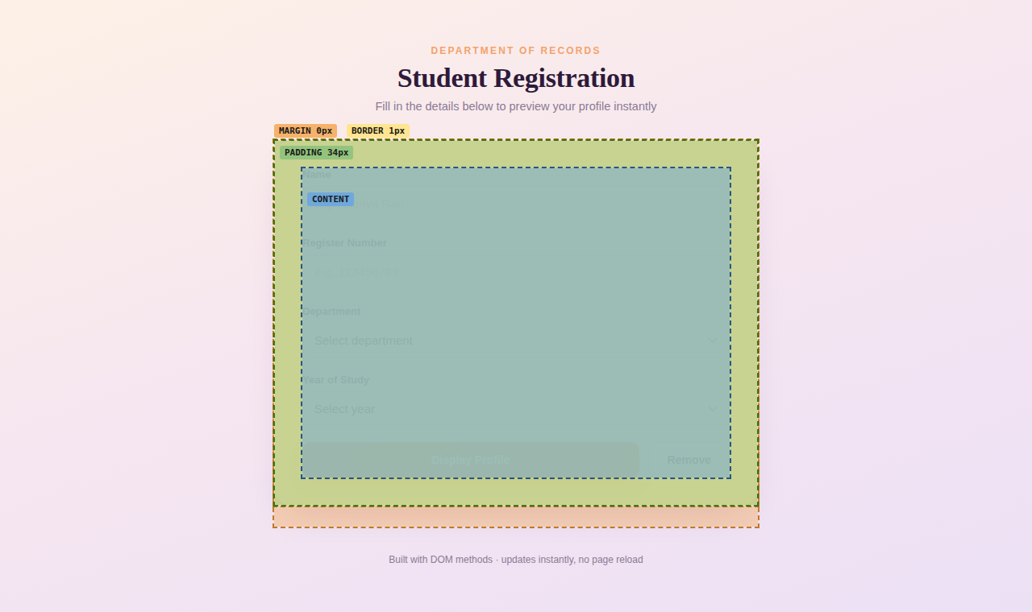

5. Responsive Verification

5.1 Desktop (1280px)
Layout at a standard desktop viewport, with a sample profile displayed after clicking “Display Profile”:
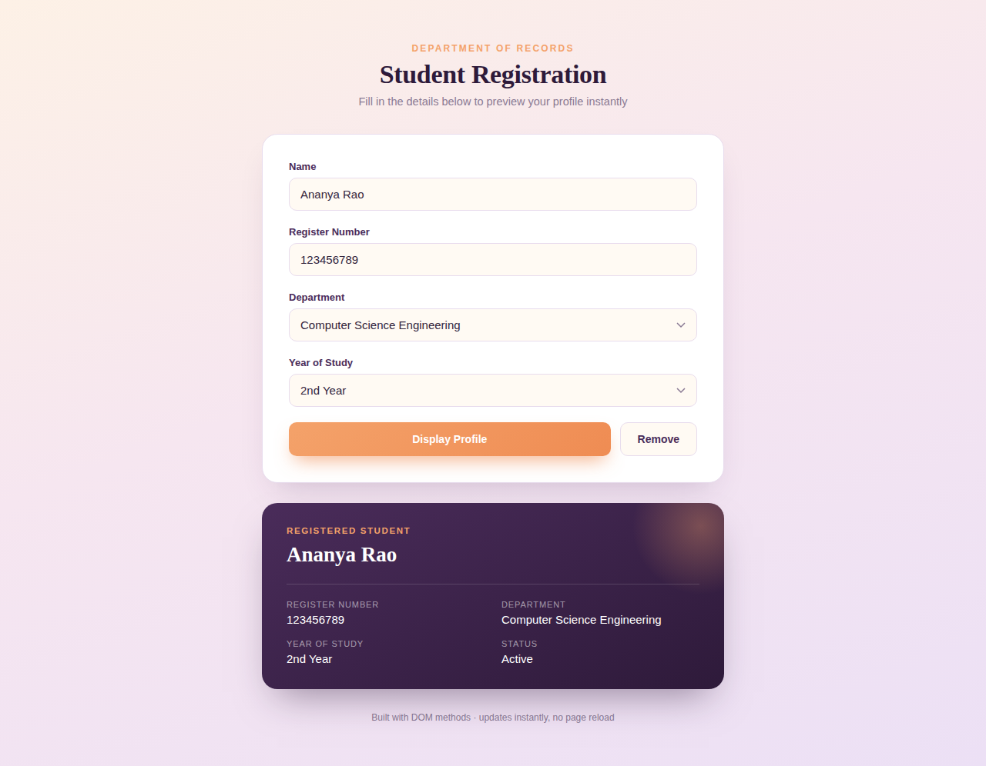

5.2 Mobile (375px)
The same interaction on a 375px-wide mobile viewport. The form and profile card both reflow to single-column, full-width layouts with no horizontal scrolling or overlap:
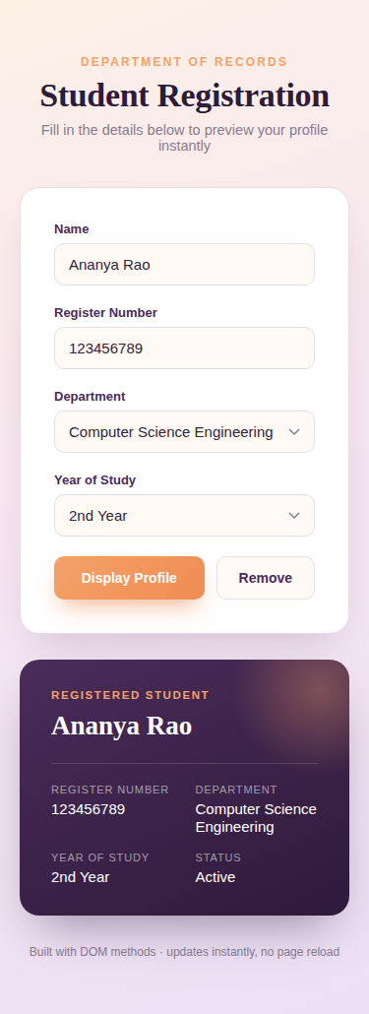

6. Concepts Assessed — Summary
DOM manipulation | createElement, appendChild, remove, textContent
Element selection | getElementById, querySelector
Dynamic content | Profile card built entirely at runtime from form input
Event handling | addEventListener for click (display/remove) and input (digit filter)
classList | profile-card class toggled on/off to distinguish generated content
Element removal | .remove() on the generated card via the Remove button

7. Conclusion
The webpage satisfies all stated requirements: form values are read via DOM selection methods, the profile is generated dynamically without a page reload, the profile is visually distinguished through a dedicated class, and it can be cleanly removed on demand. Responsive behaviour was verified at both desktop and mobile widths, and the box model of the core container was inspected and confirmed to match the values declared in style.css.

